**SE 102.3 – Web Based Application Development**

**Tutorial**

1. Write down the HTML codes required to create the following form

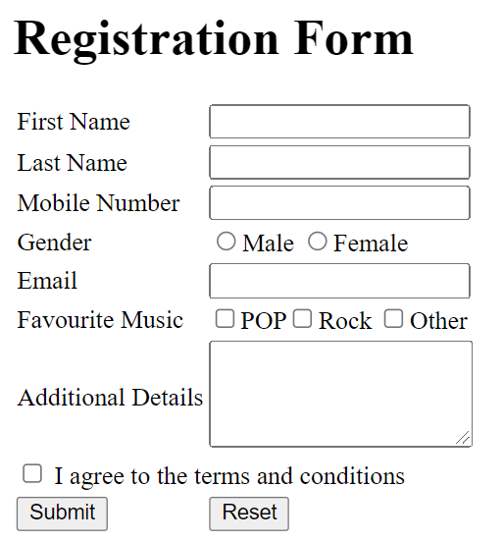

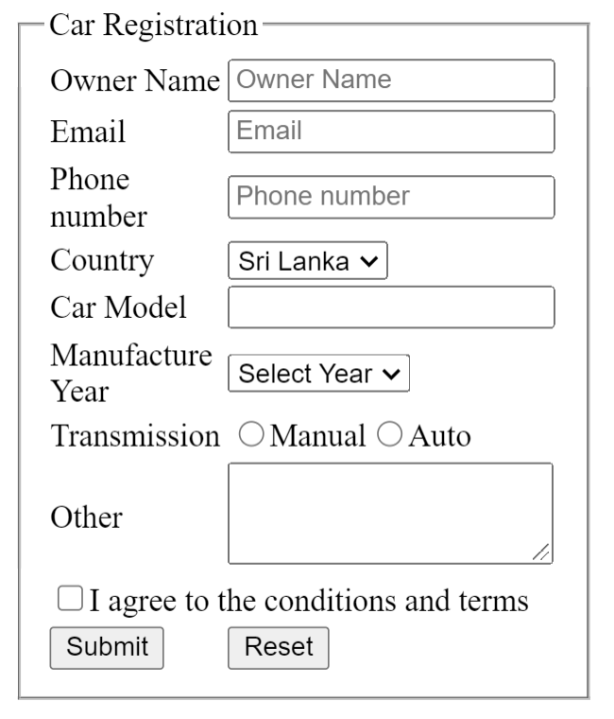

**Answers**

<!DOCTYPE html>

<html>

<head>

<title>Registration Form</title>

</head>

<body style="align:center">

<fieldset>

<form>

<table border="0" >

<tr>

<td><h1>Registration Form</h1></td>

</tr>

<tr>

<td><label for="first_name">First Name</label></td>

<td><input type="text" id="first_name" name="first_name" required></td>

</tr>

<tr>

<td><label for="last_name">Last Name</label></td>

<td><input type="text" id="last_name" name="last_name" required></td>

</tr>

<tr>

<td><label for="mobile_number">Mobile Number</label></td>

<td><input type="tel" id="mobile_number" name="mobile_number" required></td>

</tr>

<tr>

<td><label for="gender">Gender</label></td>

<td><input type="radio" id="male" name="gender" value="male">

<label for="male">Male</label>

<input type="radio" id="female" name="gender" value="female">

<label for="female">Female</label></td>

</tr>

<tr>

<td><label for="email">Email</label></td>

<td><input type="email" id="email" name="email" required></td>

</tr>

<tr>

<td><label for="favourite_music">Favorite Music:</label></td>

<td><input type="checkbox" name="POP">POP

<input type="checkbox" name="Rock">Rock

<input type="checkbox" name="Other">Other</td>

</tr>

<tr>

<td><label for="additional_details">Additional Details:</label></td>

<td><textarea id="additional_details" name="additional_details"></textarea><br></td>

</tr>

<tr>

<td><input type="checkbox">I agree to the terms and conditions.</td>

</tr>

<tr>

<td><input type="submit" value="Submit"></td>

<td><input type="reset" value="reset"></td>

</tr>

</table>

</form>

</fieldset>

</body>

</html>

……………………………………………………………………………………………………………………………………….

<!DOCTYPE html>

<html>

<head>

<title>Registration Form</title>

</head>

<body style="align:center">

<fieldset >

<legend>Car Registration</legend>

<form>

<table border="0" >

<tr>

<td><label>Owner Name</label></td>

<td><input type="text" placeholder="Owner name" required></td>

</tr>

<tr>

<td><label for="email">Email</label></td>

<td><input type="email" id="email" name="email" placeholder="Email" required></td>

</tr>

<tr>

<td><label>Phone Number</label></td>

<td><input type="tel" name="phone_number" placeholder="phone_number" required></td>

</tr>

<tr>

<td><label>Country</label></td>

<td><select id="country" name="country">

<option value="Sri Lanka" selected="Sri Lanka">Sri Lanka</option>

<option value="India">India</option>

<option value="United States">United States</option>

<option value="United Kingdom">United Kingdom</option>

<option value="Other">Other</option>

</select></td>

</tr>

<tr>

<td><label>Car Model</label></td>

<td><input type="text"></td>

</tr>

<tr>

<tr>

<td><label>Manufacture Year</label></td>

<td><select id="year" name="year">

<option value="year" selected="select year">select year</option>

<option value="2010">2010</option>

<option value="2012">2012</option>

<option value="2015">2015</option>

<option value="2018">2018</option>

<option value="Other">Other</option>

</select></td>

</tr>

<td><label for="transmission">transmission</label></td>

<td><input type="radio" id="manual" name="transmission" value="manual">

<label for="manual">Manual</label>

<input type="radio" id="auto" name="transmission" value="auto">

<label for="Auto">Auto</label></td>

</tr>

<tr>

<td><label>Other</label></td>

<td><textarea></textarea><br></td>

</tr>

<tr>

<td><input type="checkbox">I agree to the terms and conditions.</td>

</tr>

<tr>

<td><input type="submit" value="Submit"></td>

<td><input type="reset" value="reset"></td>

</tr>

</table>

</form>

</fieldset>

</body>

</html>